 | On the beat in…  North Shropshire  Market Drayton  Wem  Whitchurch  Safer Neighbourhood Team Newsletter | September2024

Current statistics on calls to police and crime recording for your neighbourhood can be found at www.police.uk. If you wish to discuss further, please contact a member of your Safer Neighbourhood Team.

Market Drayton – Team contact details:
Team email: marketdrayton.snt@westmercia.police.uk
Safer Neighbourhood Officer: PC Iain McIntosh Mobile: 07811 748 732
Police Community Support Officer: PCSO Andy King Mobile: 07870 163 116
Police Community Support Officer: PCSO Tara Carruthers Mobile: 07971 050 442
Police Community Support Officer: Mobile:

Wem – Team contact details:
Team email: wem.snt@westmercia.police.uk
Safer Neighbourhood Officer: PC Jack Harper Mobile: 07817 885 113
Police Community support Officer: PCSO Lizz Walmsley Mobile: 07967 303 567
Police Community support Officer: PCSO Olly Morris Mobile: 07970 879 117

Whitchurch – Team contact details:
Team email: whitchurch.snt@westmercia.police.uk
Safer Neighbourhood Officer: PC Ben Jones Mobile: 07973 885 557
Police Community Support Officer: PCSO Jamie Robinson Mobile: 07967 301 147
Police Community Support Officer: PCSO Dave Andrew Mobile: 07971 395 050
Police Community Support Officer: Mobile:

Our North Shropshire Parish Councils and their chosen priorities:
Market Drayton |  | Wem |  | Whitchurch
Market Drayton Town | Drugs | Wem Town | Speeding | Whitchurch Town | Drugs
 | ASB |  | ASB |  | ASB
 | Not provided |  | Thefts (Other) |  | ASD
Adderley | Farm thefts | Wem Rural | Rural Crime | Whitchurch Rural | Speeding
 | Speeding |  | Drugs |  | Thefts (Outbuilding)
 | Not provided |  | Speeding |  | Other Traffic Offences
Cheswardine | ASB | Hadnall | Speeding | Prees | Other Traffic Offences
 | Dwelling thefts |  | ASB |  | ASB
 | Not provided |  | Thefts (Out bldg) |  | Thefts (Farms)
Hinstock | Speeding | Shawbury | Speeding | Whixall | Not provided
 | Thefts |  | ASB |  | Not provided
 | RTC |  | Drugs |  | Not provided
Hodnet | Speeding | Clive | ASB | Ightfield with Calverhall | Thefts (Farms)
 | Not provided |  | Other Traffic offences |  | ASB
 | Not provided |  | Thefts (Other) |  | Not provided
Moreton Say | Thefts (Farms) | Grinshill | Speeding
 | ASD |  | Wildlife Crime
 | Speeding |  | Thefts (Other)
Norton In Hales | Not provided | Myddle, Broughton & Harmer Hill | ASB
 | Not provided |  | Criminal Damage
 | Not provided |  | Speeding
Stanton Upon Hine Heath | Speeding | Lee Brockhurst | Farm thefts
 | Thefts (Farm) |  | Speeding
 | Not provided |  | Other Traffic Offences
Stoke On Tern | Speeding | Loppington | Not provided
 | Thefts (Farms) |  | Not provided
 | Wildlife Crime |  | Not Provided
Sutton Upon Tern | Speeding
 | Thefts (Farms)
 | Thefts (Commercial)
Woore | Speeding
 | Farm thefts
 | ASB
Childs Ercall | Speed
 | Thefts (Farm)
 | ASD
Weston Under Redcastle | Not provided
 | Not provided
 | Not provided

Please encourage your parishioners to sign up to Neighbourhood Matters.

Sign up to Neighbourhood Matters… your brand-new community messaging service
 | Neighbourhood Matters enables residents, businesses, and community groups to keep in touch with local policing teams. You can choose exactly what type of alert you wish to receive and how you receive them; whether that be by email, text or telephone.  Sign up now at: www.neighbourhoodmatters.co.uk

Hello Parish Councils,

This is your North Shropshire Safer Neighbourhood Team (SNT) Newsletter for September 2024. Please see the link above to police.co.uk for crime recording stats for your area, or any other area in the UK should you wish.

Please get in touch if you would like to discuss anything further, if we can provide more information we will, our contact details are above. If there is anything specific that is affecting your parish area above and beyond the three priorities you have nominated, again please let us know and we will endeavour to support you.

The official West Mercia Police website www.westmercia.police.uk has a wealth of information and includes dedicated sections in relation to News, Recruitment, Watch Schemes, Neighbourhood Matters, Crime Prevention Advice, Support For Victims, other Advice and Information and Thanks & Complaints.

Our North Shropshire SNTs work in a very challenging and varied role and no two days are the same, naturally there are many requests for our time, support and assistance. Obviously, much of what we do we can’t tell you too much about, but rest assured that much of our focus is on the three Parish Council Priorities that you provide us with quarterly.

Much of the good work that SNTs engage with are posted in the following places:

- Parish Council reports in person or Newsletters

- Neighbourhood Matters – www.neighbourhoodmatters.co.uk

- Facebook - www.facebook.com/shropshirecops/

- Twitter – www.twitter.com/NorthShropCops

Below is just a small snapshot of the good work North Shropshire SNTs have been involved with recently…

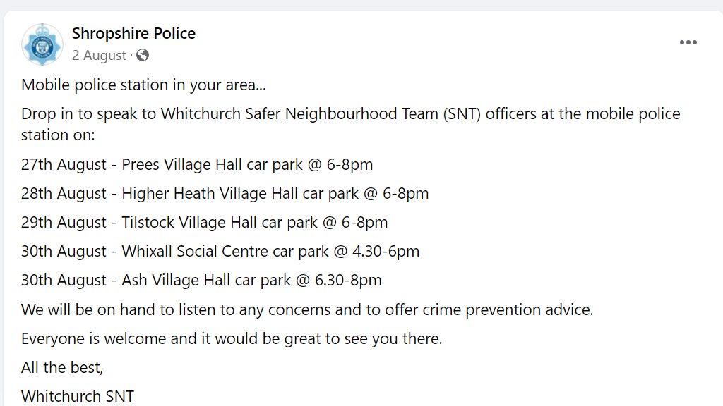

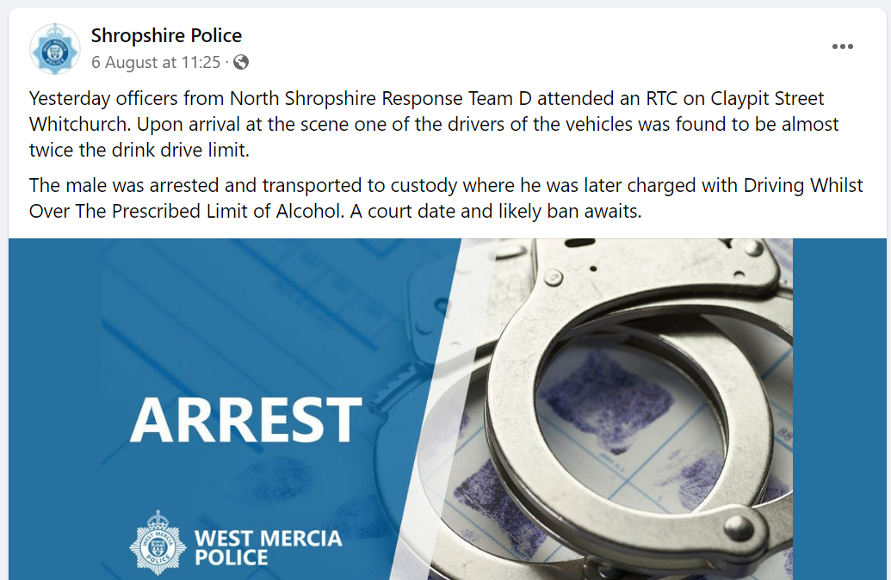

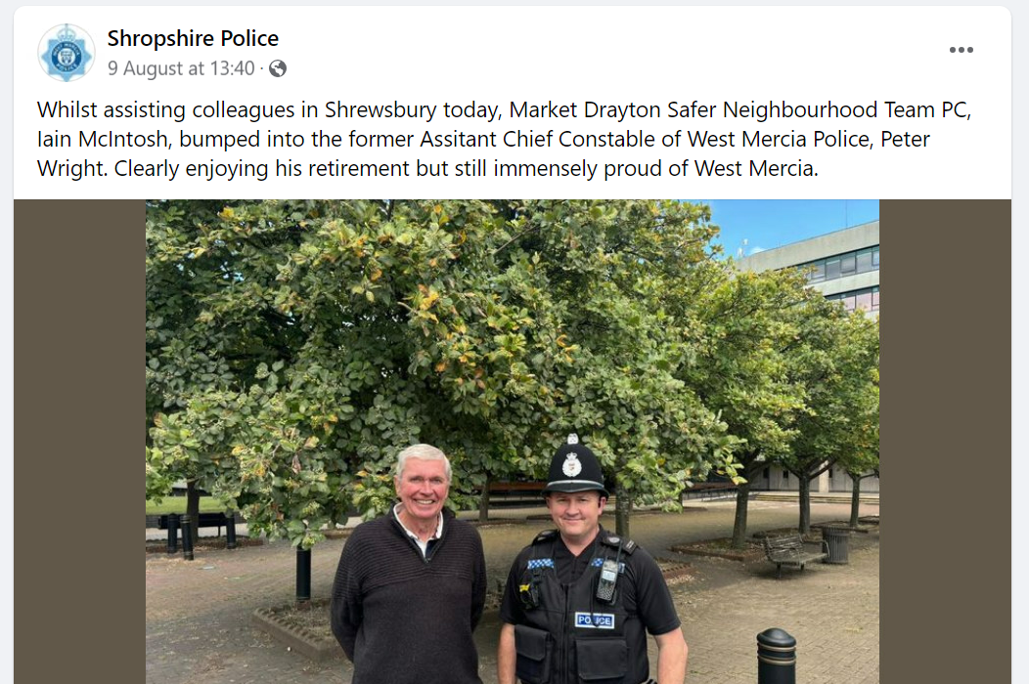

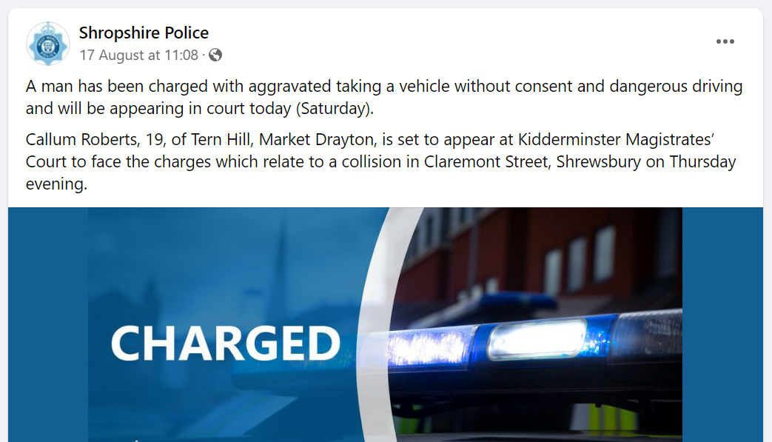

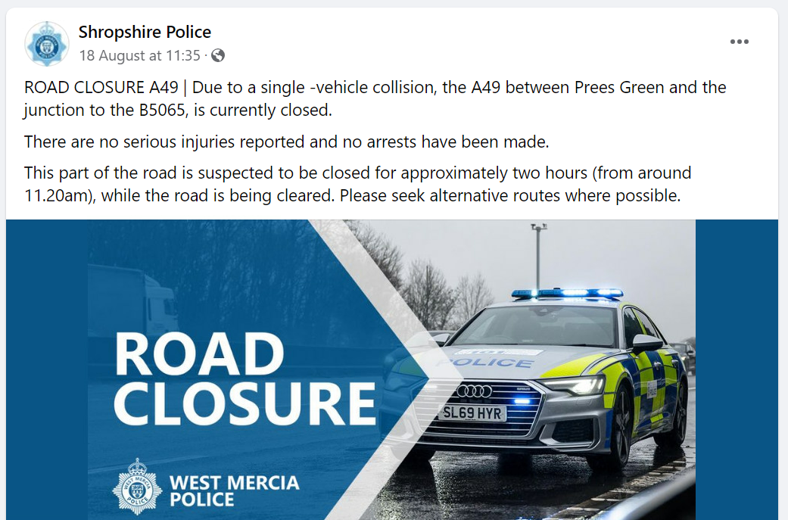

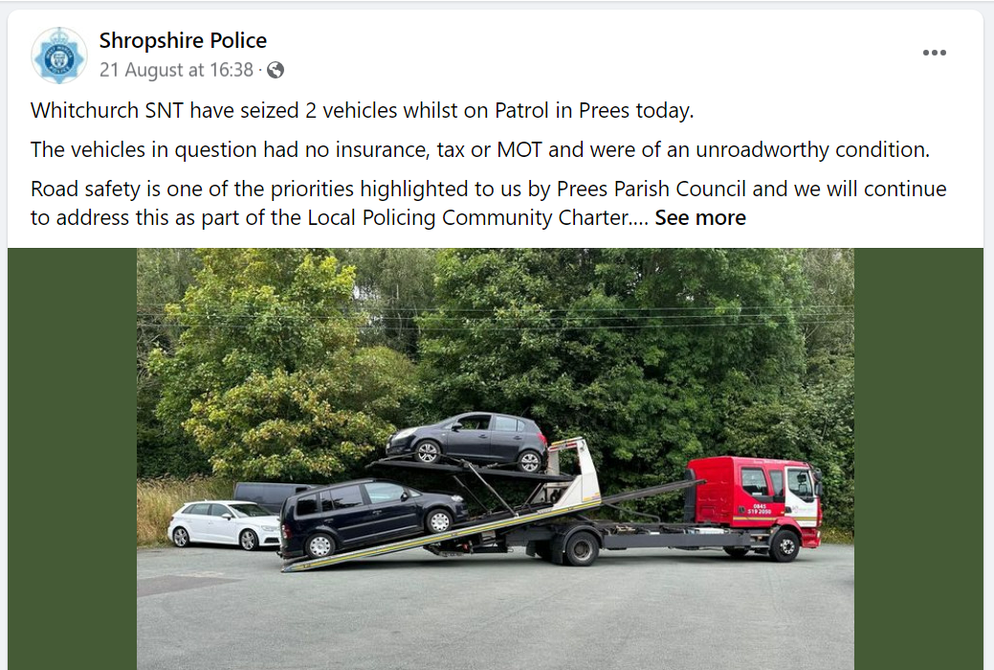

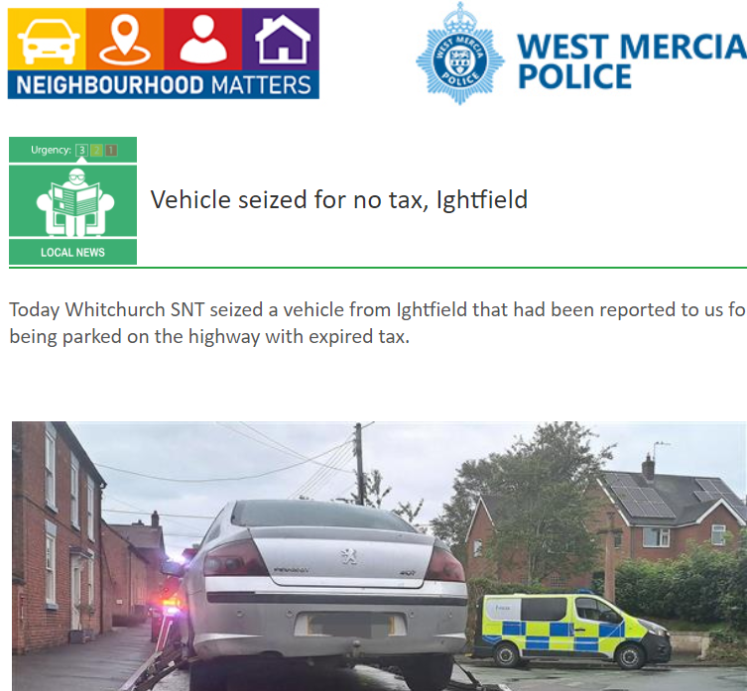

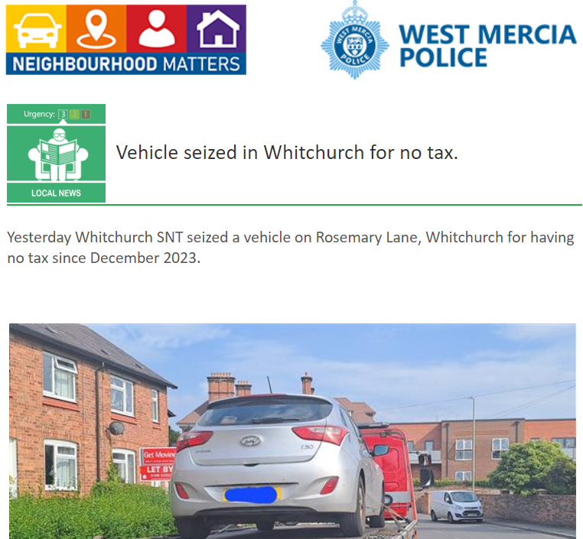

As part of the monthly Newsletter, we will be adding trending and/or appropriate crime prevention advice and information. Along with any recent updates from our other policing departments and partners.

This month’s Newsletter contains sections on ‘Rural crime’ (Parish council priority), ‘ASB’ (Parish council priority), ‘E-scooters’ (Emerging trend)

Rural crime prevention advice

Equipment and tool security
Equipment and tool security can be a particular issue for rural businesses and farms.

To keep your belongings safe:
- lock equipment away in a secure building or part of a building when not in use
- invest in a secure storage toolbox
- install a burglar alarm on buildings where equipment is kept
- always lock vehicles when left outside and keep the keys in your possession
- keep expensive items and vehicles out of sight when not in use
- consider using hitch locks, wheel clamps or ground anchors
- mark your tools and equipment and register them
- keep a record of all valuable items
- consider fitting outside security lights

Estate and building security
A good standard of building security is very important in rural areas, especially for outbuildings that may not be visited for weeks at a time.

Farmhouses and other rural properties are the same as any other home, so general home security advice still applies. However, because of the remote location, additional security measures may be beneficial.

To protect your rural home or business:
- keep the boundaries of your land and property well-maintained and secure
- keep all doors and windows shut and locked when not in use
- install a visible burglar alarm
- make sure windows and door frames are secure and in good repair
- fit strong locks to sheds, garages and outbuildings
- fit good quality window locks
- consider security bars and grilles for vulnerable windows and openings
- make sure gates cannot be lifted off or have their fixing bolts removed
- check security equipment regularly to ensure it works properly
- use locking posts or temporary obstructions to control wide access points to yards

For additional security you could also:

- install automatic security lights that come on at dusk and turn off at dawn
- install CCTV cameras to watch over the most vulnerable areas of the property
- install a monitored intruder alarm system
- install an entry control system infrared, intercom or keypad
- establish a single gated entrance and exit, removing all private access points that are not in use

Boundaries
Take a good look around your property boundary for any potential places where it could be made more secure.

Consider:
- planting thorny hedging to act as a natural barrier
- digging deep ditches to control and deter unwanted vehicle access
- if possible, having a single-gated access point to the property
- using locking posts or temporary obstructions to control large openings
- invert and cap gate hinges
- making sure fixing bolts are secure and use covered padlocks
- installing warning signs

Electric fences
Electric fences can be an easy target for thieves as they're often in remote locations away from the farm or stable.

Thieves steal them for scrap value, or offer them on second-hand markets without operating instructions.

To protect your fence and energiser, you could:
- visibly mark your equipment in a number of places as a deterrent, reducing its value and making it harder to sell on if stolen
- photograph the unit and record the make, model and serial number, to help the police if it's stolen
- attach your energiser to a sturdy fixed point or secure it in a purpose-made storage container
- hide or camouflage your energiser behind a fence or tree, in a hedge or in undergrowth
- attach a small tracker to the energiser
- cover the power light with tape

Stolen energisers are often sold on without instructions or packaging. If you see an item like this, and you're suspicious about how it's become available, please report it online.

Fire prevention
- dispose of refuse regularly and safely
- remove hay and straw from fields as soon as possible after harvesting and do not store it alongside other materials/vehicles
- store petrol, diesel and other fuels in secure areas and always padlock storage tank outlets
- seek further advice from your local fire service

Illegal activity
All incidents of illegal activity should be reported to the appropriate authority as soon as possible. If you are able to, make a note of any vehicle details and a description of the people involved.

Always consider your own personal safety first before approaching anyone you think might be doing something illegal.

Illegal occupation
As a landowner it’s your responsibility to protect your land from unauthorised occupation. Making sure your premises and boundaries are secure will greatly reduce the risk of unauthorised occupation.

To help protect your land you could:
- look closely at the perimeter to ensure it is as secure as possible
- consider using large tree trunks, rocks, ditching and earth mounds around boundaries to prevent access
- restrict vehicle access by digging deep ditches
- keep unused land maintained and free from litter and other waste

If your land does become illegally occupied, you can take proceedings to the county court to obtain a court order for the eviction of illegal occupants. Occupants who fail to comply with this notice by leaving the land as soon as reasonably possible are committing an offence.

Diesel theft
Diesel theft is a problem for many farms and rural properties. Fuel tanks stored in rural and isolated locations are very attractive to thieves looking for an easy target.

- keep tanks stored close to the property where you can see them. If this isn’t possible, you should consider installing CCTV to watch over isolated tanks and restrict access with walls, fences and hedges. Security lighting such as ‘dusk till dawn’ or motion detection lighting can also be an effective deterrent to thieves
- remember to check the oil level in your tank regularly. Look for any spilt fuel, marks on the locks or anything else suspicious
- avoid installing a storage tank in an isolated area or outlying building
- consider using a mobile bowser (tanker) kept in a secure place when not in use
- use ‘diesel dye’, making your diesel traceable and less attractive to thieves

Livestock theft
You should check your livestock and the security of boundary fencing regularly. If they're making more noise than usual this could mean something has disturbed them.

- make regular checks of the fields where animals are kept to check that fences haven’t been breached and that no one else is in the field with them
- use ear tags, horn brands, freeze marking or tattooing to make your animals more easily identifiable
- keep your hedges, fences and gates in good repair: field gate hinges should have capping hinges so they can't be removed easily; cattle grids should be removable and locked out of position when they're not in use; use locking posts to obstruct large openings to yards
- consider installing CCTV

Always report any suspicious activity involving livestock to the police.

Tack security
- secure tack room windows on the inside with solid iron bars (not tubular steel)
- secure all doors with good quality locks; use bolts (not screws) on the hinges
- mark your tack using an ultraviolet pen
- display warning signage to deter thieves
- padlock gates with substantial padlocks and heavy duty chains
- reverse top hinges on gates to prevent lifting
- install security lights and an intruder alarm

Chemical storage
- store fertilisers in a dedicated locked building or compound – don't leave them on public view
- don't sell fertiliser unless you know the potential purchaser to be a legitimate user
- record all deliveries and usage and carry out regular stock taking
- record manufacturers’ code numbers and detonation resistance test certificates – you may be required to present them
- always report a stock discrepancy or loss immediately

The Health and Safety Executive can provide further advice on storage/transportation of fertilisers, particularly ammonium nitrate.

ASB advice

Some ASB incidents might be an issue for your local council so it may be useful to know to who contact.
Here are some examples of ASB that we want to know about:
- Fireworks misuse
- Abandonment of cars
- Aggressive animals or use of animals in illegal activities
- Nuisance noise from people being inconsiderate in a public space
- Indecent, threatening or offensive phone calls
- Street drinking causing disruptive behaviour
- Vehicle nuisance such as street racing and riding unlicensed powered vehicles
Here are some examples of ASB that isn’t a police matter and your local council could be informed on:
- Someone blocking your driveway
- Stray dog that isn’t sick or injured
- Nuisance noise from pubs and clubs, and construction sites
- General littering, fly-tipping, hazardous items
- Neighbour disputes such as loud music or dogs barking, parking, property boundaries, overgrowing trees and hedges
- Trespassing without causing damage or harm

E-scooters

What is an e-scooter?
Electrical scooters (also known as e-scooters) come under the category of “powered transporters”; this covers a range of personal transport devices which are powered by a motor.

E-scooters are classed as motor vehicles under the Road Traffic Act 1988. Which means the rules that apply to motor vehicles, also apply to e-scooters including the need to have a licence, insurance and tax.

It's not currently possible to get insurance for privately owned e-scooters, which means it's illegal to use them on the road or in public spaces. If you're using a private e-scooter you risk the vehicle being seized under S.165 Road Traffic Act 1988 for no insurance.

If you cause serious harm to another person whilst riding an e-scooter the incident will be investigated in the same way it would if you were riding a motorcycle or driving a car.

Rental e-scooter trials
Trials of rental e-scooters are taking place in the UK. Anyone using a rental e-scooter on a public road or other public space, has to comply with the relevant road traffic legislation or they face potential prosecution.

To rent an e-scooter you must:
- meet the minimum age limit; these can vary depending on the provider, so please check with them
- hold the correct driving licence (category Q or P/M)
- create an account with the rental company

E-scooters can only be used in approved areas.

Legal use of an e-scooter
It's legal to use an e-scooter on private land with the permission of the land owner.
Where a trial rental scheme is running, it's legal to use a rental e-scooter on a public road or cycle lane, provided you have the correct licence and follow road traffic regulations.
Penalties and offences
If you don't have a licence, or the correct licence, or are riding without insurance you could face a
Fixed Penalty Notice.

Forces set and enforce penalties differently, so the penalty will vary depending on where the offence is committed.
If you are in Devon and Cornwall, the police will not issue fines, so other forms of penalty will be used if you use an e-scooter in a public place when not part of an approved trial.
For other forces in the UK and Northern Ireland, the Fixed Penalty Notice could include:
- a £300 fine and six penalty points on your licence for having no insurance
- a £100 fine and three to six penalty points for riding without the correct licence
You could also be committing an offence if you're caught:
- riding on a pavement; Fixed Penalty Notice and possible £50 fine
- using a mobile phone or other handheld mobile device while riding; £200 and six penalty points
- riding through red lights; Fixed Penalty Notice, £100 fine and possible penalty points
- drink driving: the same as if you were driving a car, you could face court imposed fines, a driving ban and possible imprisonment

If you're using an e-scooter in public in an antisocial manner, you can also risk the e-scooter being seized under section 59 of the Police Reform Act.
When riding an e-scooter, we would always recommend wearing safety protection such as a helmet and to keep to the speed limit.

Are you aware of Community Speed Watch, and is it relevant to your parish?

With Community Speed Watch now in its eighth year of operation within West Mercia, local communities are being reminded about the scheme and how volunteers can get involved in speed monitoring and improve the quality of life in their area if speeding traffic is causing concern.
Community Speed Watch is a community driven road safety initiative, coordinated by West Mercia Police but managed and run by volunteers in the community. It involves trained volunteers from the community monitoring the speeds of vehicles with approved, hand-held speed measurement devices. Where vehicle speeds are found to be inappropriate, a letter is sent to the registered keeper by the police with the aim of encouraging them to reduce their speed when driving in the future.
The scheme was introduced within West Mercia in 2014 and has gone from strength to strength over the last 8 years with over 40 active sites currently operating. It was introduced to enhance the force’s speed enforcement strategy, by addressing community concerns in areas that do not meet either speed or collision criteria for police-led enforcement.

A Community Speed Watch scheme is initiated when ‘speeding traffic’ has been identified as a community road safety concern by a parish council or Safer Neighbourhood Team. However, several criteria must be met before a scheme can be established:
- The area must have a 30mph or 40mph speed restriction.
- Speed data collected by West Mercia Police must show that speed levels in the area do not meet the national industry requirements for police enforcement.
- No other enforcement activity is currently in place.
- There must be at least six volunteers in each Community Speed Watch scheme.
- Speed checks must be conducted by at least three volunteers at any one time.

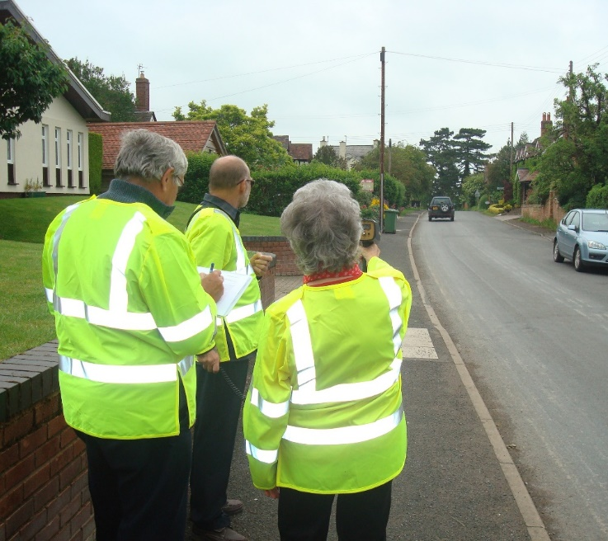

The contacts below may be of interest to those in the parish who may be more comfortable reporting crime or giving information to the police, anonymously:

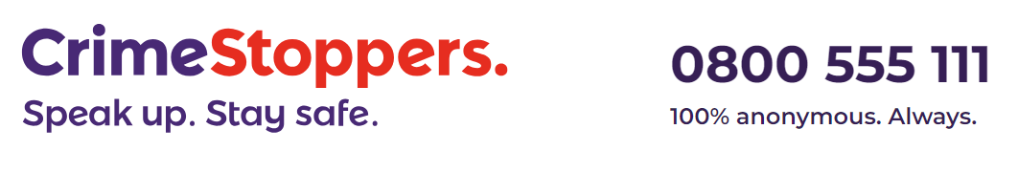
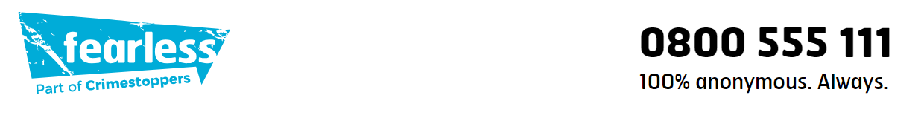

Are your parishioners aware of Action Fraud?

If you’ve been the victim of a scam, fraud or online crime (cybercrime) you can report it to Action Fraud:
- Action Fraud website
- on 0300 123 2040 (Monday to Friday 8am to 8pm).
Action Fraud is the national reporting centre for fraud and cybercrime. It collects reports about fraud on behalf of the police in England, Wales and Northern Ireland. For fraud in Scotland please report it directly to Police Scotland.

