 | On the beat in…  North Shropshire  Market Drayton  Wem  Whitchurch  Safer Neighbourhood Team Newsletter | November  2024

Current statistics on calls to police and crime recording for your neighbourhood can be found at www.police.uk. If you wish to discuss further, please contact a member of your Safer Neighbourhood Team.

Market Drayton – Team contact details:
Team email: marketdrayton.snt@westmercia.police.uk
Safer Neighbourhood Officer: PC Iain McIntosh Mobile: 07811 748 732
Police Community Support Officer: PCSO Andy King Mobile: 07870 163 116
Police Community Support Officer: PCSO Tara Carruthers Mobile: 07971 050 442
Police Community Support Officer: Mobile:

Wem – Team contact details:
Team email: wem.snt@westmercia.police.uk
Safer Neighbourhood Officer: PC Jack Harper Mobile: 07817 885 113
Police Community support Officer: PCSO Lizz Walmsley Mobile: 07967 303 567
Police Community support Officer: PCSO Olly Morris Mobile: 07970 879 117

Whitchurch – Team contact details:
Team email: whitchurch.snt@westmercia.police.uk
Safer Neighbourhood Officer: PC Ben Jones Mobile: 07973 885 557
Police Community Support Officer: PCSO Jamie Robinson Mobile: 07967 301 147
Police Community Support Officer: PCSO Dave Andrew Mobile: 07971 395 050
Police Community Support Officer: Mobile:

Our North Shropshire Parish Councils and their chosen priorities:
Market Drayton |  | Wem |  | Whitchurch
Market Drayton Town | Drugs | Wem Town | Speeding | Whitchurch Town | Drugs
 | ASB |  | ASB |  | ASB
 | Not provided |  | Thefts (Other) |  | ASD
Adderley | Thefts (Farm) | Wem Rural | Rural Crime | Whitchurch Rural | Speeding
 | Speeding |  | Drugs |  | Thefts (Outbuilding)
 | Not provided |  | Speeding |  | Other Traffic Offences
Cheswardine | ASB | Hadnall | Speeding | Prees | Other Traffic Offences
 | Dwelling thefts |  | ASB |  | ASB
 | Not provided |  | Thefts (Out bldg) |  | Thefts (Farms)
Hinstock | Speeding | Shawbury | Speeding | Whixall | ASD
 | Thefts |  | ASB |  | Thefts (Farms)
 | RTC |  | Drugs |  | Thefts (Out bldg)
Hodnet | Speeding | Clive | ASB | Ightfield with Calverhall | Thefts (Farms)
 | Not provided |  | Other Traffic offences |  | ASB
 | Not provided |  | Thefts (Other) |  | Not provided
Moreton Say | Thefts (Farms) | Grinshill | Speeding
 | ASD |  | ASB
 | Speeding |  | Thefts (Other)
Norton In Hales | Not provided | Myddle, Broughton & Harmer Hill | ASB
 | Not provided |  | Criminal Damage
 | Not provided |  | Speeding
Stanton Upon Hine Heath | Speeding | Lee Brockhurst & Moreton Corbett | Thefts (Farm)
 | Thefts (Farm) |  | Speeding
 | Not provided |  | Other Traffic Offences
Stoke On Tern | Speeding | Loppington | Not provided
 | Thefts (Farms) |  | Not provided
 | Wildlife Crime |  | Not Provided
Sutton Upon Tern | Speeding
 | Thefts (Farms)
 | Thefts (Commercial)
Woore | Speeding
 | Theft (farm)
 | ASB
Childs Ercall | Speeding
 | Thefts (Farm)
 | ASB
Weston Under Redcastle | Not provided
 | Not provided
 | Not provided

Please encourage your parishioners to sign up to Neighbourhood Matters.

Sign up to Neighbourhood Matters… your brand-new community messaging service
 | Neighbourhood Matters enables residents, businesses, and community groups to keep in touch with local policing teams. You can choose exactly what type of alert you wish to receive and how you receive them; whether that be by email, text or telephone.  Sign up now at: www.neighbourhoodmatters.co.uk

Hello Parish Councils,

This is your North Shropshire Safer Neighbourhood Team (SNT) Newsletter for October 2024. Please see the link above to police.co.uk for crime recording stats for your area, or any other area in the UK should you wish.

Please get in touch if you would like to discuss anything further, if we can provide more information we will, our contact details are above. If there is anything specific that is affecting your parish area above and beyond the three priorities you have nominated, again please let us know and we will endeavour to support you.

The official West Mercia Police website www.westmercia.police.uk has a wealth of information and includes dedicated sections in relation to News, Recruitment, Watch Schemes, Neighbourhood Matters, Crime Prevention Advice, Support For Victims, other Advice and Information and Thanks & Complaints.

Our North Shropshire SNTs work in a very challenging and varied role and no two days are the same, naturally there are many requests for our time, support and assistance. Obviously, much of what we do we can’t tell you too much about, but rest assured that much of our focus is on the three Parish Council Priorities that you provide us with quarterly.

Much of the good work that SNTs engage with are posted in the following places:

- Parish Council reports in person or Newsletters

- Neighbourhood Matters – www.neighbourhoodmatters.co.uk

- Facebook - www.facebook.com/shropshirecops/

- Twitter – www.twitter.com/NorthShropCops

Below is just a small snapshot of the good work North Shropshire SNTs have been involved with recently…

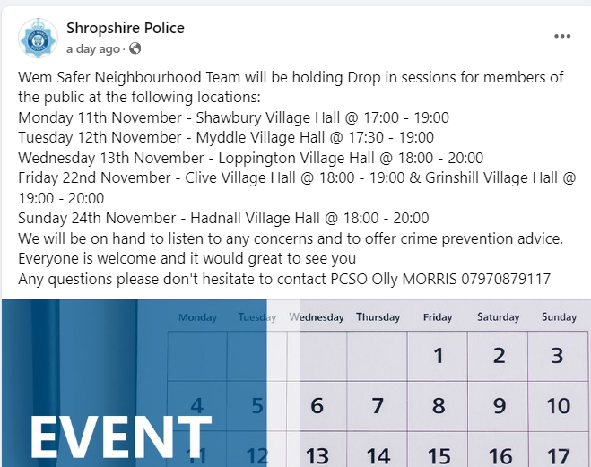

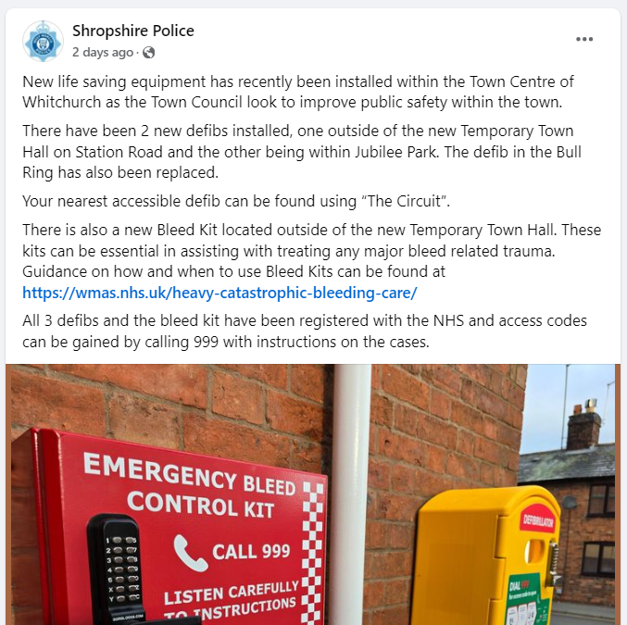

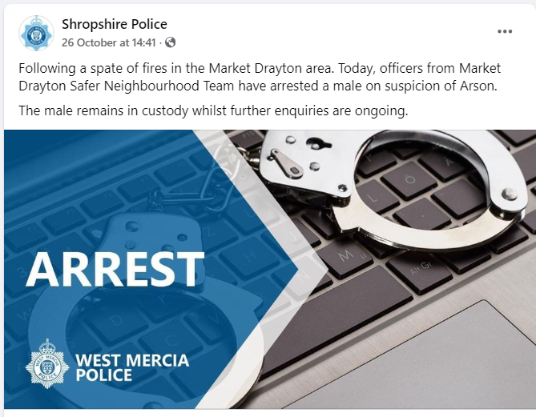

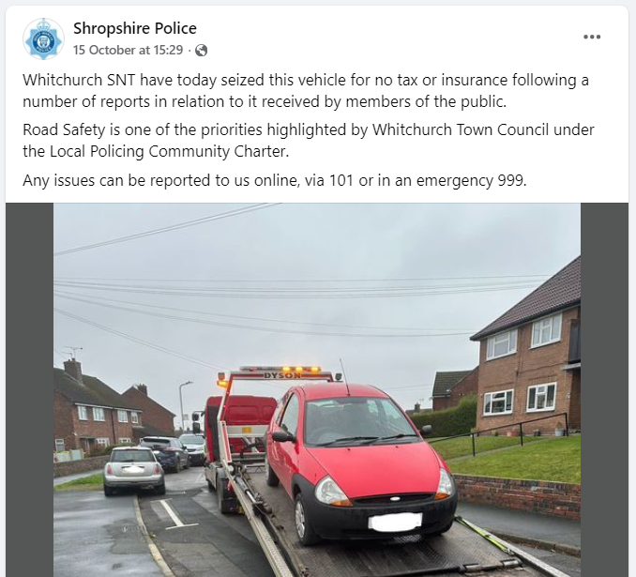

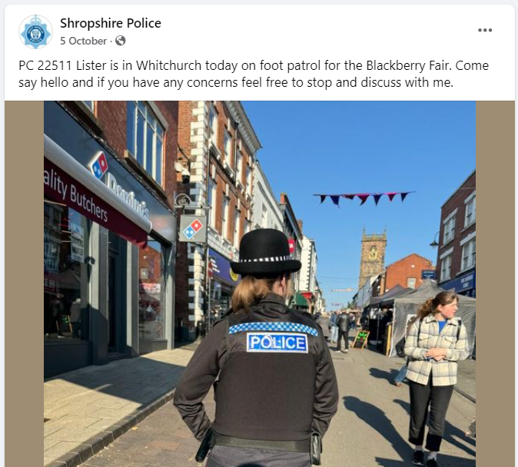

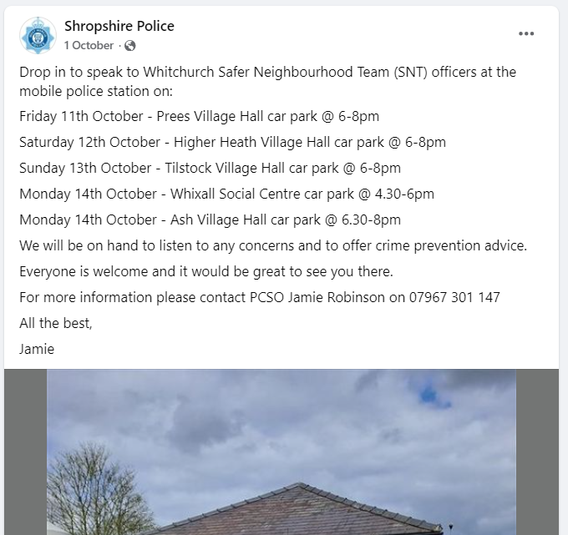

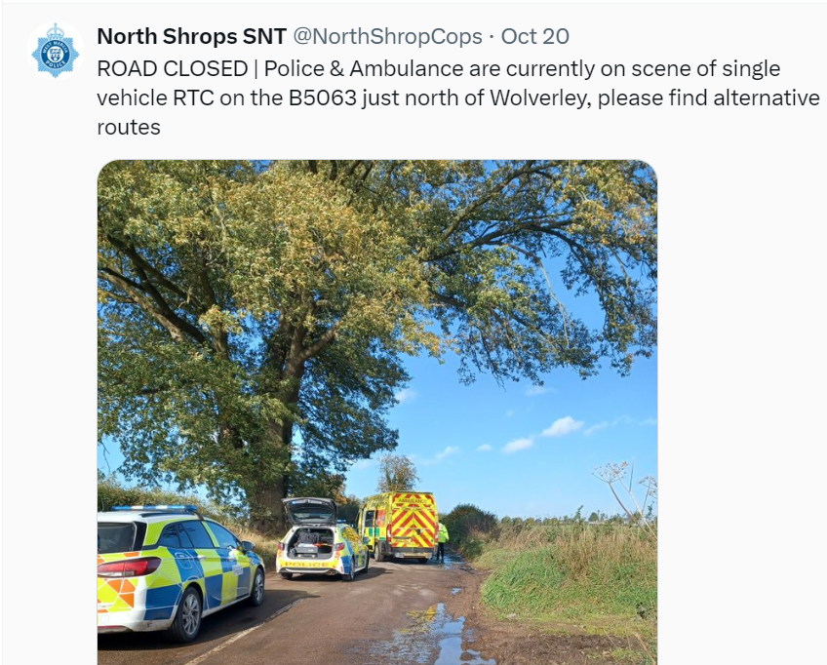

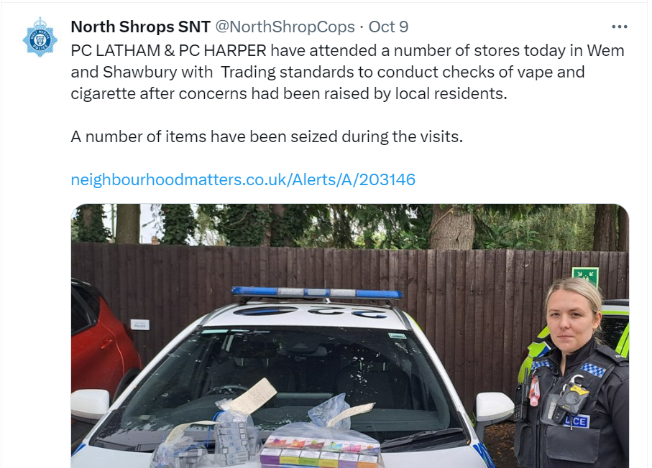

As part of the monthly Newsletter, we will be adding trending and/or appropriate crime prevention advice and information. Along with any recent updates from our other policing departments and partners.

This month’s Newsletter contains sections on ‘Pickpocketing’ (suspicious incident in Whitchurch), ‘Operation SNAP’ (parish council priority), ‘Burglary/Thefts advice’ (parish council priority)

Pickpocketing

You may have an idea of what a pickpocket looks like but they’re far less likely to stand out in a crowd than you might think since blending in is part of how they avoid being caught. Here’s how to spot a potential pickpocket and avoid losing your belongings to one.

How to spot a pickpocket

The observers
These include people loitering in public places who appear to be checking out passers-by, paying particular interest to their handbags, shopping bags and where they might place their wallet or purse.
For example, be aware of individuals who appear to be focusing their attention on the waist area of others. This may be an indication of criminal intent and probable theft. But do bear in mind the fact that some people are naturally shy and do avoid eye contact. Always follow your instincts.
The opportunists

Pickpockets also operate in shops and department stores, where people are more likely to be standing still, distracted and so paying less attention to their belongings, making them an easier target.

Be more aware of your surroundings in busy shops and shopping centres because they’re ideal places for pickpockets, as it’s easier for them to brush past people, take items and blend into the crowd.

Team tactics
Pickpockets don’t always operate alone, they may work in teams to distract the target while someone unseen removes the items and blends back into the crowd. Another member might step in as an enforcer in the event of an altercation.

Crowding in
Thieves vary their tactics based on the location and the density of the crowd. One tactic is where a group of them push up against a victim in a crowded shop or street then quickly reach into the victim’s pocket and steal their wallet, phone or purse.

Dirty tricks
Remember, pickpockets are very skilled at what they do. They know all the tricks and are extremely light-fingered with most of their thefts only taking a second or two. One of their tactics is ‘hugger mugging’ where a thief will appear to be over-friendly for no particular reason and hug you while pickpocketing you.

The point of distraction
Pickpocket teams are adept at creating distractions. This could be anything from a game to a loud shout, all designed to avert your attention while an unseen accomplice steals your valuables. So do try not to be easily distracted.
Are you a prime target?

Dos

- Do keep purses and bags closed and secure at all times
- Do carry bags in front of you or diagonally across your chest
- Do return cards to your purse or wallet quickly and zip it up or button it
- Do use a purse that’s difficult to open. One that zips or snaps shut is best, and keep it closed
- Do use a money belt if you’re carrying a significant quantity of cash
- Do conceal your wallet in a buttoned or zipped pocket where it doesn’t bulge
- Do keep a list, separate from your wallet and phone, of contact numbers of family in case your phone is stolen
- Do keep a photocopy of your airline tickets, passport, credit cards and any other documents that would be impossible or inconvenient to replace if stolen
Don'ts

- Don’t hang stuff on the back of a chair.
- Don’t leave anything on the back of a pushchair.
- Don’t place your belongings out of sight on the floor.
Remember, having a zipped bag doesn’t mean you’re totally safe. Thieves have been known to walk behind victims while slowly unzipping bags. Yes, they can be that bold. So, never underestimate a pickpocket

Operation SNAP

As part of Operation Snap, members of the public can report and submit digital footage showing potential traffic offences via a secure online form.

This can range from driving dangerously or carelessly to overtaking on solid white lines, using a mobile phone while driving, ignoring traffic lights or dangerous driving around other road users, such as horse riders and cyclists.

Please note; issues with number plates, windscreens and minor traffic offences are unable to be dealt with via Op Snap.

Please DO NOT report road traffic collisions through Operation Snap. These should be reported online at Road collisions and incidents | West Mercia Police

General parking complaints (other than illegal parking on zig zags) should be raised with the relevant local authority. Notification of untaxed vehicles can be reported directly to DVLA, reports of no MOT or no insurance should be logged to 101, not via the Op Snap portal.

Your submission will be sent to West Mercia Police where the evidence will be reviewed by one of our road traffic police officers.

One statement is required for each submission/offending vehicle. We are unable to process multiple offences sent as one submission.

We will strive to update each submitter regarding the outcome of their allegation. All submissions are dealt with pro-actively to help reduce risk taking and poor driving on our counties roads.
Any footage submitted through the portal can be used by us to help educate other road users and to advise on case results.

Please note - if you operate a recording device in a public place, you may have obligations under the General Data Protection Regulation (GDPR). It is in your interest to familiarise yourself, and comply with, any such obligations as apply to you. If you are in any doubt as to your obligations, please obtain independent legal advice to ensure you do not put yourself at risk of prosecution. By submitting footage you acknowledge you have read and understood this before proceeding.
For more information, please see the Frequently Asked Questions section or email OpSnap@westmercia.police.uk

Burglaries

With darker nights still upon us, we are sharing some simple ways to protect your home.

Popping out of the house?

- Close and lock all your doors and windows, even if you’re only going out for a few minutes!
- Double-lock any door
- Make sure that any valuables are out of sight – this includes leaving packaging from outside of your house
- Keep handbags away from the letterbox or cat flap and hide all keys including car keys, as a thief could hook keys or valuables through even a small opening
- Never leave car documents or ID in obvious places such as kitchens or hallways
- In the evening, shut the curtains and leave lights on
- If you’re out all day, then it’s advisable to use a timer device to automatically turn lights and a radio on at night
- Set your burglar alarm
- Make sure the side gate is locked
- Lock your shed or garage
- Lock your bike inside a secure shed or garage, to a robust fitting bolted to the ground or wall, like a ground anchor

Going away?

- If you’re off on holiday and wish to post anything on social media, make sure your posts aren’t public and that they’re only seen by your friends – you don’t want potential burglars to know your house will be unattended!
- Leave lights and a radio on a timer to make your house appears occupied
- Ask a trusted neighbour to keep an eye on your property, or you could join a Neighbourhood Watch Scheme to keep in touch with those in your street
- Consider asking your neighbours to close curtains after dark
- If your driveway will be empty – you could also ask a neighbour to park on there to deter burglars from breaking in
- Remember to cancel newspaper and milk deliveries – you don’t want these piling up on your doorstep!

Are you aware of Community Speed Watch, and is it relevant to your parish?

With Community Speed Watch now in its eighth year of operation within West Mercia, local communities are being reminded about the scheme and how volunteers can get involved in speed monitoring and improve the quality of life in their area if speeding traffic is causing concern.
Community Speed Watch is a community driven road safety initiative, coordinated by West Mercia Police but managed and run by volunteers in the community. It involves trained volunteers from the community monitoring the speeds of vehicles with approved, hand-held speed measurement devices. Where vehicle speeds are found to be inappropriate, a letter is sent to the registered keeper by the police with the aim of encouraging them to reduce their speed when driving in the future.
The scheme was introduced within West Mercia in 2014 and has gone from strength to strength over the last 8 years with over 40 active sites currently operating. It was introduced to enhance the force’s speed enforcement strategy, by addressing community concerns in areas that do not meet either speed or collision criteria for police-led enforcement.

A Community Speed Watch scheme is initiated when ‘speeding traffic’ has been identified as a community road safety concern by a parish council or Safer Neighbourhood Team. However, several criteria must be met before a scheme can be established:
- The area must have a 30mph or 40mph speed restriction.
- Speed data collected by West Mercia Police must show that speed levels in the area do not meet the national industry requirements for police enforcement.
- No other enforcement activity is currently in place.
- There must be at least six volunteers in each Community Speed Watch scheme.
- Speed checks must be conducted by at least three volunteers at any one time.

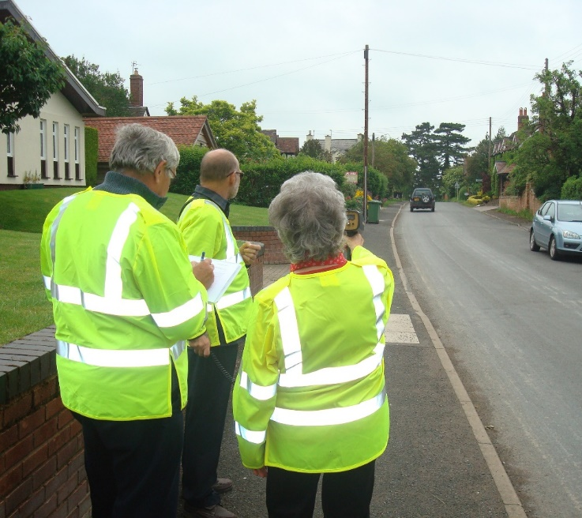

The contacts below may be of interest to those in the parish who may be more comfortable reporting crime or giving information to the police, anonymously:

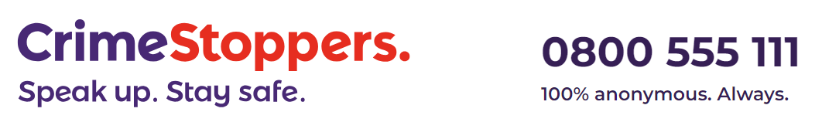


Are your parishioners aware of Action Fraud?

If you’ve been the victim of a scam, fraud or online crime (cybercrime) you can report it to Action Fraud:
- Action Fraud website
- on 0300 123 2040 (Monday to Friday 8am to 8pm).
Action Fraud is the national reporting centre for fraud and cybercrime. It collects reports about fraud on behalf of the police in England, Wales and Northern Ireland. For fraud in Scotland please report it directly to Police Scotland.






